**The idea:** An application inspired to [Lidl plus](https://play.google.com/store/apps/details?id=com.lidl.eci.lidlplus&hl=en)

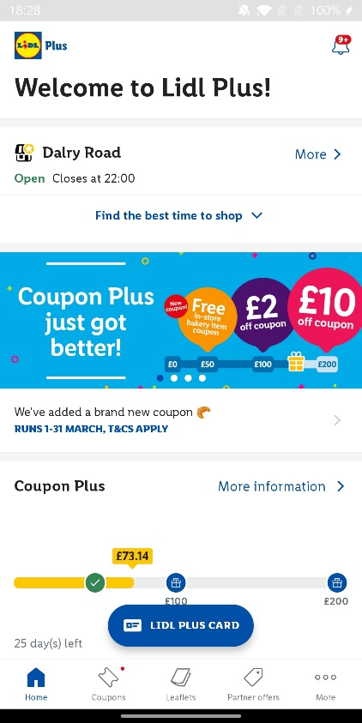<https://play.google.com/store/apps/details?id=com.lidl.eci.lidlplus&hl=en>

**What is included:**

Home screen:

* Welcome message
* Local store
* Coupons



Bottom menu/navbar:

* Home
* Coupons



* Leaflets
* Settings

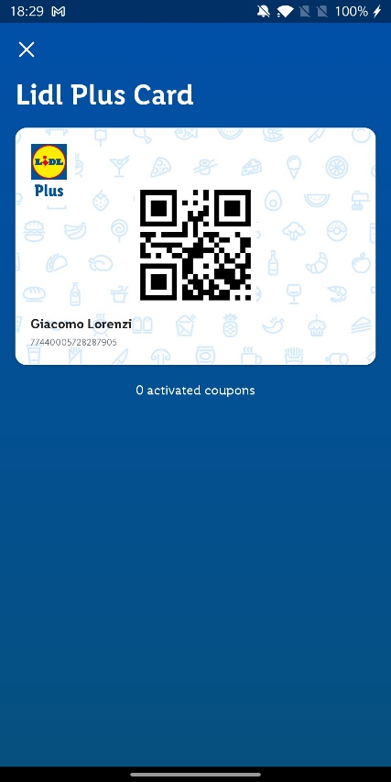Card screen:

Coupons:

* Coupons and expiration date

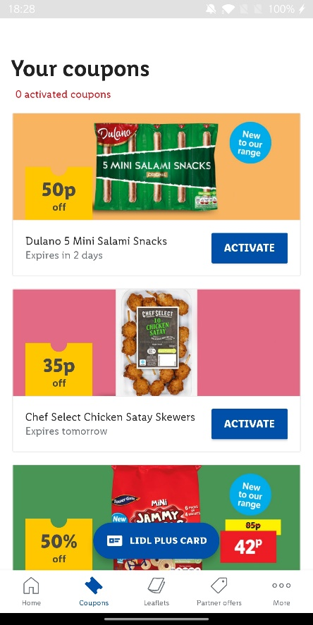

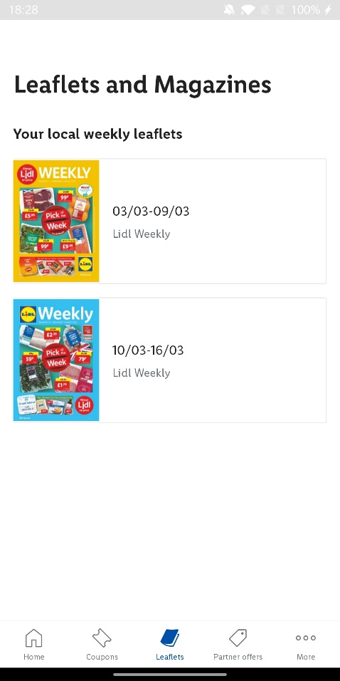Leaflets:

* Pdf version of the paper leaflets

available in store

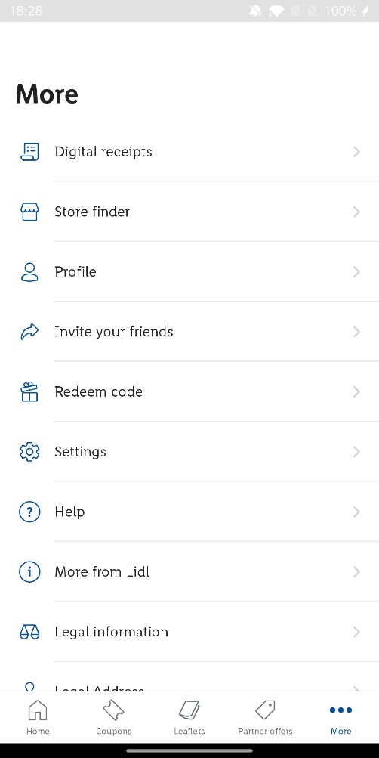More:

* Digital receipts
* Legal information
* Settings

